

Volunteer Role |  | Small Animal and Reptile Volunteer
Availability |  | 2-5 hours per week  Tuesday, Wednesday, Thursday, Friday or Saturday
Location |  | Ouseburn Farm Charity Ltd, Ouseburn Road, Newcastle, NE1 2PA
For more information and/or to apply for this role |  | Email: volunteering@ouseburnfarm.org.uk  or call Sarah on 07816 978309
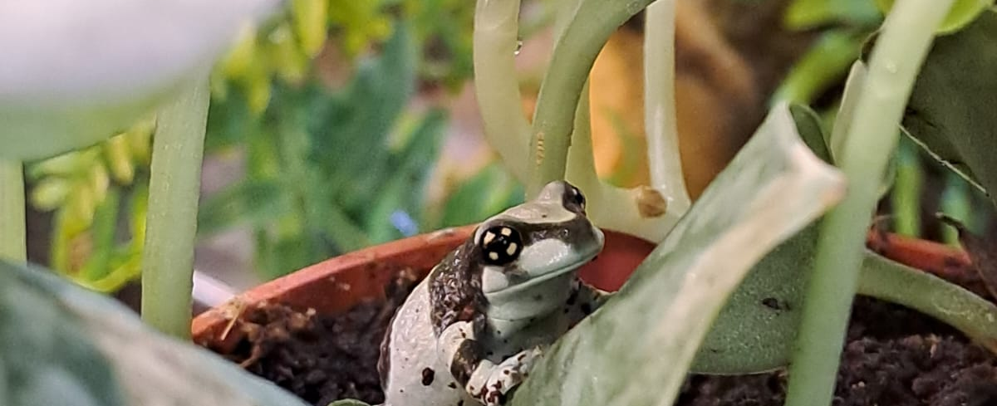

About this volunteer role
Ouseburn Farm is a charity and working community farm in the urban heart of Newcastle upon Tyne. Our story started in 1976 when parents from Byker took over a plot of land on the site where the Farm is now. They wanted their children to have access to nature, to grow their own food and take care of animals.

We are now a registered charity and remain true to our origins, giving over 40,000 visitors a year the opportunity to learn about the origins of food and care for nature through engagement with farm life.

We are also a care farm and our placement programme for autistic adults and adults with learning disabilities and difficulties is central to our work. We help our placements to learn new skills and connect with nature, each other and their community through meaningful activity in our farmyard, gardens, kitchen, café and visitor centre.

All activities are inspired by and take place in and around our working farmyard, gardens, on site café (run by Smile for Life Children’s Charity) and popular visitor centre.
As a Small Animal and Reptile Volunteer, you will volunteer directly with the animals and will be required to ‘get your hands dirty’. You will be involved in feeding, weighing, cleaning, animal enrichment and handling small animals and reptiles as well as general animal welfare.

Role responsibilities
- Follow daily and weekly cleaning rotas to ensure the small animal and reptile room is kept clean and tidy
- Ensure animal feed stations are kept clean and clear of algae
- Feed small animals and reptiles in line with feeding guide
- Weigh assigned animals and reptiles weekly and complete weighing records
- Complete regular small animal and reptile health checks and keep records up to date
- Record animal behaviours and health
- Make enrichment toys or devices for the small animals and reptiles
- Be aware of animal welfare
- Share information about the animals with members of the visiting public
- Become familiar with Ouseburn Farm’s ethos and history
- Keep up to date with current activities and services on offer

Knowledge, skills and experience
- Knowledge of small animal and reptile welfare
- Experience of studying, volunteering or working in animal care
- Willing to get dirty as part of your volunteer role
- Reliability and flexibility to volunteer on a range of tasks
- Willing to commit to this role for at least 6 months for a minimum of one session per week
- Experience of volunteering or working in a community setting (desirable but not essential)

Check requirements
As part of the application process, Ouseburn Farm request 2 character references and a DBS check.

Learning and development
- Complete mandatory training, as required. This includes but is not limited to Safeguarding, Health and Safety and GDPR
- Attend Ouseburn Farm’s Volunteer Induction
- Attend scheduled volunteer meetings
General Information
- We always act in accordance with the Ouseburn Farm’s Code of Conduct policy
- We comply with the workplace health and safety management system
- We demonstrate skill, knowledge and behaviour to work with vulnerable adults in a respectful and enriching way
- Volunteers will be reimbursed for travel in line with our Volunteer Policy
- Volunteers can enjoy free refreshments and receive a 20% discount at on-site café, Café Beam

What is in it for you?
As well as making a difference to a locally loved community resource, set among the beautiful surroundings of The Ouseburn, this is a great opportunity to meet people from a wide variety of backgrounds and to gain experience of volunteering as part of a small, dedicated team.
You will learn a lot about how we work with animals, the ethos here at Ouseburn Farm and absorbing, first-hand, the day-to-day life here.
As part of our promise to all of our volunteers, you will receive an introductory Volunteer Induction as well as role specific training and support to help you carry out your volunteer role confidently and competently.
As an Ouseburn Farm Small Animal and Reptile Volunteer, you will gain valuable experience of volunteering in a farm setting within a visitor centre and care farm environment. If you are looking to gain work or move into an animal care or veterinary setting, this could greatly enhance your CV.

