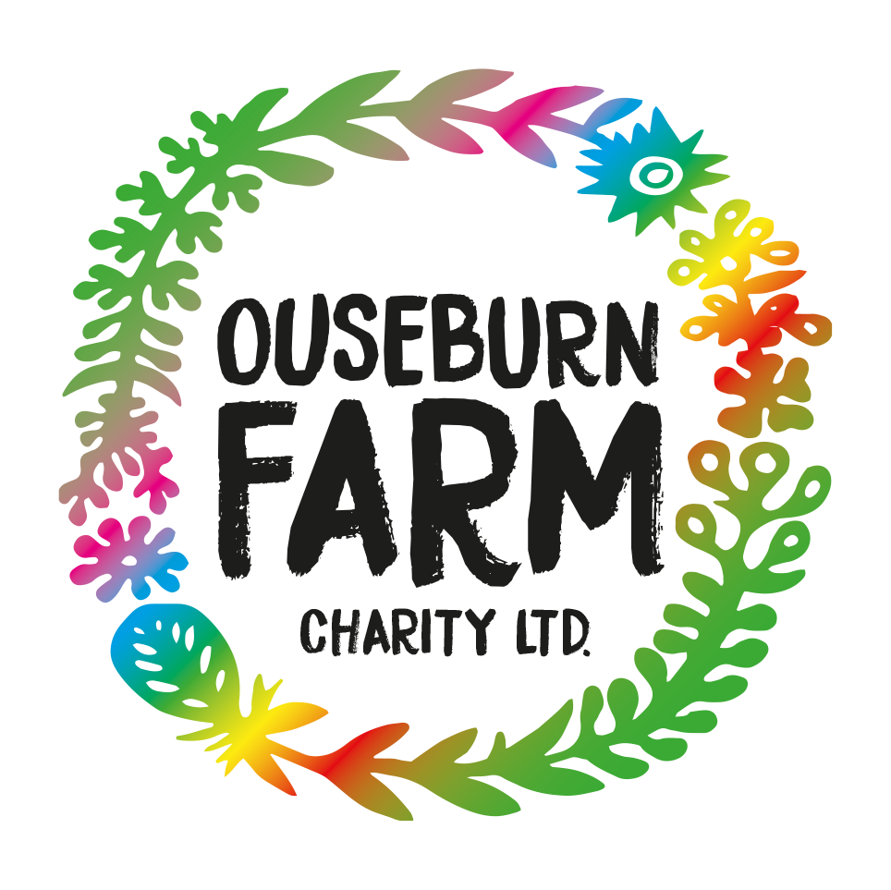

Project Brief: Children’s Activity Book
Ouseburn Farm - 50 Years of Growing
Purpose
To create a children’s story and activity book that celebrates Ouseburn Farm’s 50 year history and brings its past, present, and future to life for young visitors.
Background
Founded in 1976, Ouseburn Farm has evolved from an industrial site into a community care farm and visitor centre. As part of its 50th anniversary programme, the farm is exploring its heritage, gathering local stories, and engaging the community to shape its next 50 years. Families with young children make up a large proportion of visitors, driving the need for a creative, child-friendly way to share the farm’s story.
Project overview
The project will result in a colouring and activity book co-created with young people and designed to engage children both on-site and beyond the local community.
Key elements include:
- 2 x 2 hour children’s workshops to explore the farm’s history and help co-create content.
- A 24-page colouring/activity book, featuring animal and gardening themed scenes from the farm’s past, present, and future.
- A downloadable digital version for schools and families.
- Retail distribution via the Farm Shop, extending impact beyond the anniversary year.
Book specifications
- 18 full-page illustrated colouring pages
- 6 interactive activity pages with prompts, partial illustrations, and instructions
Audience
Children and families visiting Ouseburn Farm, as well as schools and families accessing the digital version.
Location and contract
- Remote working, with occasional visits to Ouseburn Farm
- Part-time / flexible contract
Deliverables
- Workshop engagement and creative consultation
- Research, illustration, and design of a print-ready book (including cover)
- Final black-and-white digital artwork suitable for print and download
Application requirements
- Relevant experience and portfolio
- Cost breakdown and overall quote
- Current availability
Please send your proposal to jennifer.urwin@ouseburnfarm.org.uk by the 8th of February.

